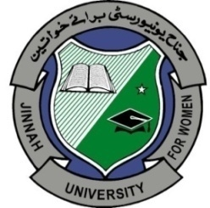**JINNAH UNIVERSITY FOR WOMEN**

**Under the auspices of Quaid-e-Azam Mohammad Ali Jinnah**

**Pakistan’s First Women University**

**Chartered by Sindh Provincial Assembly**

**Recognized by Higher Education Commission**

**Member INQAAHE**

**(International Network for Quality Assurance Agencies in Higher Education)**

**ISO Certified**

**9001:2008**

Narmeen Bawany  
Chairperson and Dean Faculty of Science